Exercise 3 – PaaS

- In your groups, fill out the following table by researching what PaaS services the three major cloud providers offer:

 | Google Cloud Platform | Microsoft Azure | Amazon Web Services
App Service
Function
Container Service
Kubernetes Service

Exercise 4 – Workflow design
Solution:
https://github.com/agray998/QAA-Module5-Workflow-Design-Solution

- Take some time to study and understand the following solution architecture for a web application:
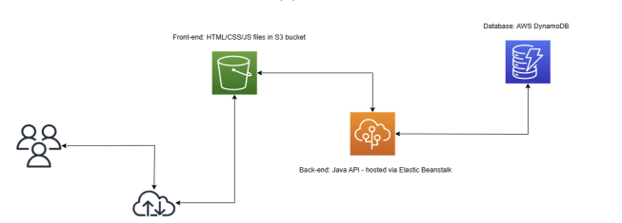
- Try to design a workflow to build and deploy the above from source code.
Note: you do not need to implement this, your task is to design the workflow.
Your design should consider:
- What tasks need to be performed in order to build and deploy each component?
- Are there any available modules which facilitate these tasks?
- What sensitive information might your workflow need access to?
How would you store this information?

